June 30, 2021

Python Project for Data Science: Stock market data analysis

IBM Professional Certificate

Data Analyst: Julio César Morales Ramírez

Villahermosa, Tabasco.

**IBM Professional Certificate: Python Project for Data Science**

**Stock market analysis**

**Overview**

In this project I will focus on an analysis of the stock market, extracting financial data like historical share price and quarterly revenue reporting from different sources using Python libraries and Webscraping from popular stocks. After collecting the data, I’m going to extract KPI’s and I will visualize the data in a Dashboard to find patterns and trends. I’m going to focus in the GameStop and Tesla stocks for the central project, and Amazon and AMD stocks for certain examples.

It’s my first time in this domain, so I’m excited to see how the area of finances is, although I know is only a glance of this vast domain.

At last, this project is base in the 5th course of the IBM Professional Certificate of Coursera.

**Objectives:**

* Acquire my first overview in the domain of finances.
* Obtain a general overview of the stock market.
* Find patterns, trends and KPI’s that can help customers and companies on their future investments in stocks.

**Tools:**

* Python
* Visual Studio Code
* Jupyterlab
* Github
* Microsoft Word
* Optional: Excel and SQL.

**CONTENT**

* **Part 0:** Background.
* **Part 1:** Data Collection.
* **Part 2:** Data Visualization.
* **Part 3:** Insights and decision making.
* **Part 4:** Conclusions.
* **Part 5:** Glossary.
* **Part 6:** Bibliography.

**PART 0: BACKGROUND**

Determining the price of a stock is complex, it depends on a large number of factors. For example: profits, if the profits of a stock are rising, the stock price should increase. But sometimes, the predictions are wrong, like the stocks of Tesla a few years ago, and the Gamestop Short Squeezing of 2021 (in which a Reddit group called WallStreetBets started buying into shares of Gamestop, that cause an increment in the shared prices of the stock, and trigger a huge loss of billions of dollars in Hedge Funds. But how are the stocks of these companies now? Can my clients may considerer future investments in this companies? The goal of this project is to answer these and more questions that may arise.

**PART 1: DATA COLLECTION**

1. yfinance (Yahoo Finance) library from Python:

With the help of the yfinance libray (and the module Ticker), I extract the historical stock data of GameStop and Tesla and save it in a Data Frame.

GameStop Historical Stock Data.

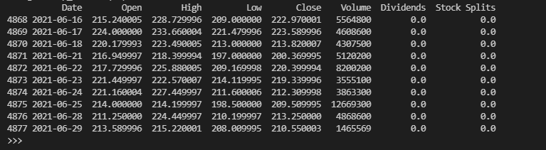

Tesla Historical Stock Data.

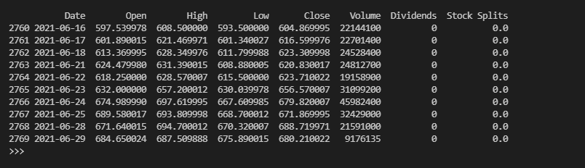

1. Webscraping:

Using website <https://www.macrotrends.net>, I extract the revenue data of Tesla and Gamestop and save it in Data Frames, also I did some Data Wrangling on the two tables, removing certain signs and handling some null and empty values.

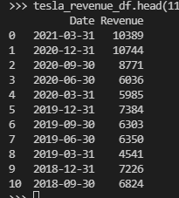 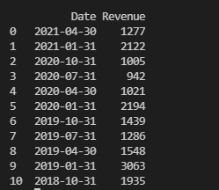

Tesla Revenue (2009-2021) GameStop Revenue (2006-2021)

**PART 2: Data Visualization**

The Notebook course provided me with a made function that receive the Data Frames created in the collection of data as inputs, I copied and understood the function in Visual Studio Code for a better knowledge acquisition.

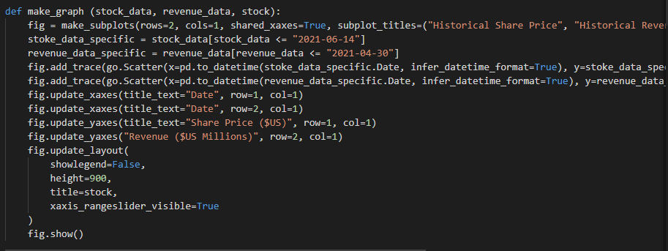

With the function defined, I only Input the data in it, and the Outputs are the plots.

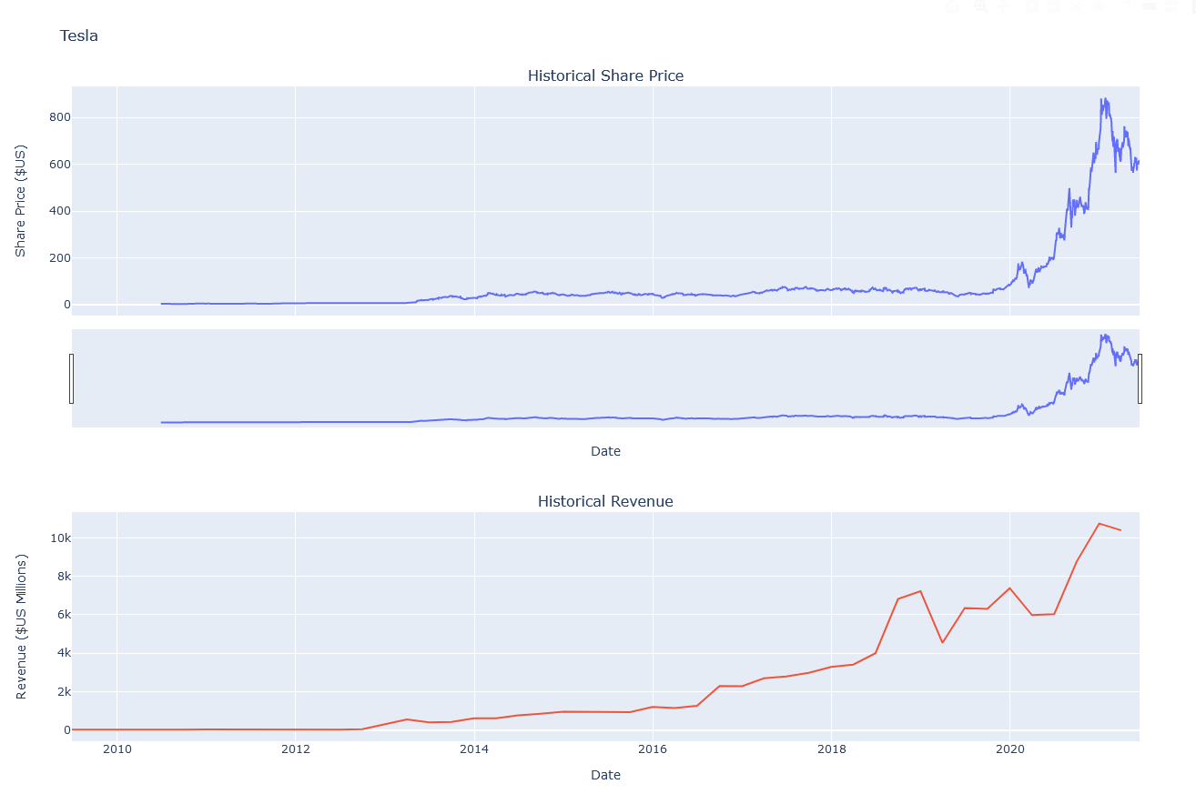

Tesla plots.

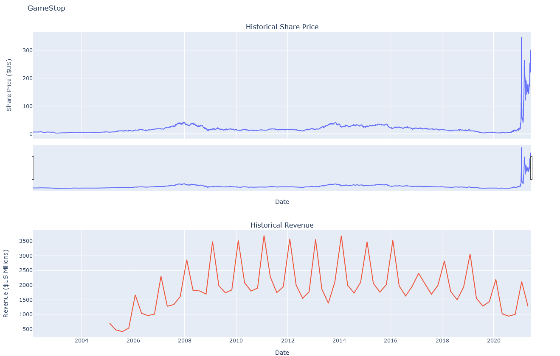

GameStop plots.

**PART 3: Insights and decision making**

**Tesla**

In general, we can see a trend of price increase that peaked on January 2021, when the Share prices of Tesla reached $883.06 USD, since that the prices have been declining, reaching the price of $617.79 USD on June 14, 2021. In the Revenue area we can see a general trend of revenue increase, that after a peak of $10.744B on December, 2020, had a small declining at the beginning of 2021.

There are two choices depending on the needs of the clients:

1. **Short Selling**: Seen the declining trend of Tesla Shares this year, we can put into practice the methodology of Short Selling, but care should be taken, since Tesla is exponentially growing company and due the increase trend in the Revenue, we can infer that this declining trend will soon end, and a bad practice of Short Shelling or and not be prevented can lead to Short Squeezing.
2. **Become a Shareholder**: If a client has high economic resource, Shares of Tesla are secure investment, seen the increase trend in the revenue, and decrease in the Share prices, there is not better time to become a Shareholder.

**GameStop**

In general, we can see how GameStop has been a struggling company over the past decade, but, with event GameStop Short Squeezing of January 2021, the company has had an extraordinary year in comparison with the past years, but by the looks of it, it won’t last long.

The Share prices had their peak of $347.41 USD on January 27, 2021, followed by a huge (but expected) declining of prices (reaching $40.59 USD on February 19, 2021), then a moderate increase again, and after that, Share prices have stabilized a little in a range between $160 and $300 USD, with the last recorded price of $229.44 USD.

In the Revenue area, we can observe a very marked inconsistency, with very high Ups and very low Downs, but with a tendency of decline over the past years. Even with the GameStop Short Squeezing 2021 (year which the Revenue had a peak of $2.122B USD) the tendency has continued, reaching a Revenue of $1.277B USD in April, 2021.

Seen the declining tendency of the revenues, we can infer that the stabilized prices of the Shares will end in a future, and with that, the prices will decline, so I recommend a **Short Selling** method for this stock, but only for this year, and looking at the background of this company, do it with all the necessary precautions.

**PART 4: Conclusion**

In this analysis of the stock market we could see that Tesla is a with a good present and a bright future, and this is shown in the behavior of their Shares, concluding that investments in Tesla are profit secure (either with Short Selling in this year or becoming in a shareholder). On the other hand, even with the extraordinary event GameStop Short Squeezing from earlier this year, the declining trend in the Revenue of the Shares turn their Shares insecure investments.

**Glossary**

* **Short Selling/Corto:** Practice in the investment area, in which an attempt is made to take advantage of inferences of Assets price, these are the following steps:

1. Borrow of the asset.
2. Selling of the borrowed asset.
3. Buy of the borrowed asset (inferring a decline in prices).
4. Return of the borrowed asset to the company or person (Obtaining profits).

* **Crowdsourcing:** Work model in which an open group of individuals (external on what is considered employees) work together to make and offer ideas, services, task execution, etc.; to an organization, company or individual.
* **Short squeeze/Estrangulamiento de posiciones cortas:** In the Stock Market, it’s a rapidly increase of Share prices, given the increase of demand and small supply of Assets, due to erroneous predictions in Short Selling.
* **Asset/Activo:** Any resource owned or controlled by a company, business or an individual. It’s anything than can produce money.
* **Liquid Asset/Activos líquidos:** Type of asset that can be converted in cash very quickly. Examples: Funds in your bank account, cash in hand.
* **Financial Assets:** Nonphysical assets, whose values defined from a contractual claim. Examples: Bank deposits, Stock.
* **Security/Valor:** A tradable Financial Asset.
* **Stock shares/Acciones:** Is a security that represents the ownership of a fraction of a company. The owners of stocks have a proportion of the corporation assets and profits equal to how much stock they own.
* **Stock Ticker:** A report of a certain stock that is update continuously.
* **Dividends:** The distribution of company profits to shareholders, the amount of money for every shareholder depends in the number of shares owned.
* **Volume (stocks):** Total number of shares traded in a traded day or a specified period of time.
* **Virtual environment:** Isolated programming environments, in which the interpreter, libraries and scripts of these environments may be different from others and by default, different from the environment of your OS.

**Bibliography**

* Investopedia. 2021. *Short Selling*. [online] Available at: <https://www.investopedia.com/terms/s/shortselling.asp> [Accessed 29 June 2021].
* En.wikipedia.org. 2021. *Crowdsourcing - Wikipedia*. [online] Available at: <https://en.wikipedia.org/wiki/Crowdsourcing> [Accessed 29 June 2021].
* En.wikipedia.org. 2021. *Short squeeze - Wikipedia*. [online] Available at: <https://en.wikipedia.org/wiki/Short_squeeze> [Accessed 29 June 2021].
* Investopedia. 2021. *Dividend*. [online] Available at: <https://www.investopedia.com/terms/d/dividend.asp> [Accessed 29 June 2021].
* Macrotrends.net. 2021. *Tesla Revenue 2009-2021 | TSLA*. [online] Available at: <https://www.macrotrends.net/stocks/charts/TSLA/tesla/revenue> [Accessed 30 June 2021].
* Macrotrends.net. 2021. *GameStop Revenue 2006-2021 | GME*. [online] Available at: <https://www.macrotrends.net/stocks/charts/GME/gamestop/revenue> [Accessed 30 June 2021].